# Assignment 2

Task 1- Create a class name as “Trainer” which will have 4 fields name, department , email, id. Trainer can teach Selenium, DevOps, Web Development.

Note- use method, constructor

Trainer details are

Trainer 1 – “Mukesh” ,”Testing”,[mukesh@gmail.com](mailto:mukesh@gmail.com), 1

Trainer 2 – “Hitesh” ,”Dev”,[mukesh@gmail.com](mailto:mukesh@gmail.com), 2

Trainer 1 – “Mukesh” ,”DevOps”,[mukesh@gmail.com](mailto:mukesh@gmail.com), 3

Trainer 1 can teach Selenium, Trainer 2 can teach Web Development, Trainer 3 can teach DevOps.

**Program:**

**package** assignment2;

**class** Trainee

{

String name,department,email;

**int** id;

Trainee(String name,String department,String email,**int** id)

{

**this**.name=name;

**this**.department=department;

**this**.email=email;

**this**.id=id;

}

**void** display()

{

**for** (**int** i=1;i<=3;i++)

{

//i=i+1;

//Trainer 1 can teach Selenium

System.***out***.println("Trainer"+" " + id + " "+ "can teach" + " "+department );

**break**;

}

}

}

**public** **class** Trainer {

**public** **static** **void** main(String[] args) {

Trainee t1=**new** Trainee("Mukesh" ,"Testing","mukesh@gmail.com", 1);

Trainee t2=**new** Trainee("Hitesh" ,"Dev","mukesh@gmail.com", 2);

Trainee t3=**new** Trainee("Mukesh" ,"DevOps","mukesh@gmail.com", 3);

t1.display();

t2.display();

t3.display();

}

}

**package** assignment2;

**class** Trainee

{

String name,department,email;

**int** id;

Trainee(String name,String department,String email,**int** id)

{

**this**.name=name;

**this**.department=department;

**this**.email=email;

**this**.id=id;

}

**void** display()

{

**for** (**int** i=1;i<=3;i++)

{

//i=i+1;

//Trainer 1 can teach Selenium

System.***out***.println("Trainer"+" " + id + " "+ "can teach" + " "+department );

**break**;

}

}

}

**public** **class** Trainer {

**public** **static** **void** main(String[] args) {

Trainee t1=**new** Trainee("Mukesh" ,"Testing","mukesh@gmail.com", 1);

Trainee t2=**new** Trainee("Hitesh" ,"Dev","mukesh@gmail.com", 2);

Trainee t3=**new** Trainee("Mukesh" ,"DevOps","mukesh@gmail.com", 3);

t1.display();

t2.display();

t3.display();

}

}

Task 2- Extension of task 1 – Store all trainer information in Array.

Program:

**package** assignment2;

**class** Train

{

String[] name={"Mukesh","Hitesh","Mukesh"};

String[] department= {"Testing","Dev","DevOps"};

String[] email= {"mukesh@gmail.com","mukesh@gmail.com","mukesh@gmail.com"};

**int**[] id= {1,2,3};

Train()

{

**this**.name=name;

**this**.department=department;

**this**.email=email;

**this**.id=id;

}

**void** display()

{

**for** (**int** i=0;i<3;i++)

{

System.***out***.println("Trainer"+" " + id[i] + " "+ "can teach" + " "+department[i] );

}

}

}

**public** **class** Task2 {

**public** **static** **void** main(String[] args) {

Train t1=**new** Train();

t1.display();

}

}

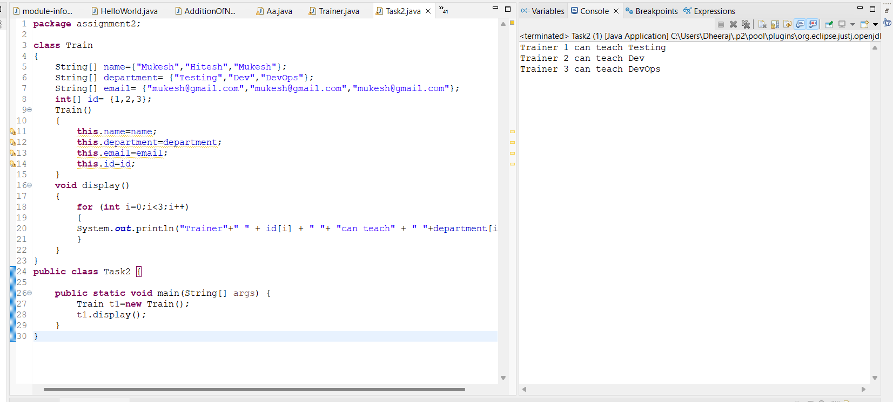

Task 3 – Create a program which will store students information and print the output.

Program should ask how many students information you want to store. For each students it should ask name, email, phone, address, status

Once all entries are done, program should ask which user information you want to fetch and should print the same.

Note- Use scanner class for dynamic students

Program:

**package** assignment2;

**import** java.util.Scanner;

**public** **class** Task3 {

**public** **static** **void** main(String[] args) {

Scanner sc = **new** Scanner(System.***in***);

System.***out***.println("Enter the Number of Student:");

**int** num = sc.nextInt();

sc.nextLine();

String[] names = **new** String[num];

String[] emails = **new** String[num];

String[] phones = **new** String[num];

String[] addresses = **new** String[num];

String[] statuses = **new** String[num];

**for** (**int** i = 0; i < num; i++) {

System.***out***.print("Pleae Enter Name: ");

names[i] = sc.nextLine();

System.***out***.print("Pleae Enter Email: ");

emails[i] = sc.nextLine();

System.***out***.print("Pleae Enter Phone: ");

phones[i] = sc.nextLine();

System.***out***.print("Pleae Enter Address: ");

addresses[i] = sc.nextLine();

System.***out***.print("Pleae Enter Status: ");

statuses[i] = sc.nextLine();

System.***out***.println();

}

System.***out***.print("Pleaase Enter which student id details are you looking for:");

**int** studentID = sc.nextInt();

System.***out***.println(names[studentID-1]);

System.***out***.println(emails[studentID-1]);

System.***out***.println(phones[studentID-1]);

System.***out***.println(addresses[studentID-1]);

System.***out***.println(statuses[studentID-1]);

}

}

